TP Visualisation

**DB : country_wise_latest.csv**

*Map : Confirmed, Deaths*

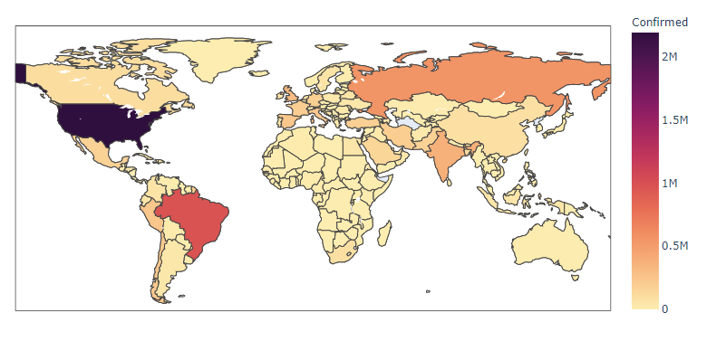

*Top 20 countries :* Confirmed, active, new cases, deaths, recovered

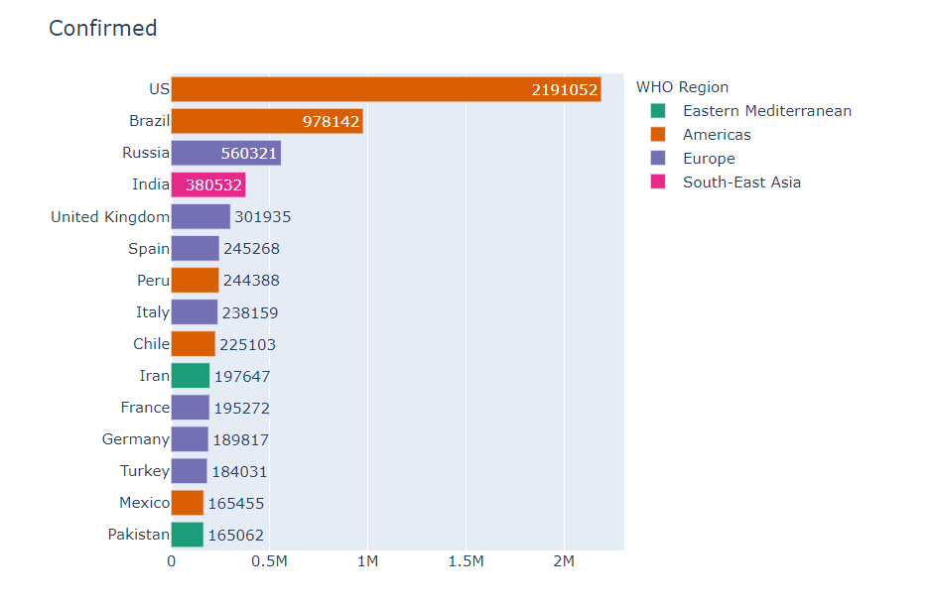

**DB : day_wise**

*Confirmed, Active, new cases, deaths, new deaths, recovered, new recovered*

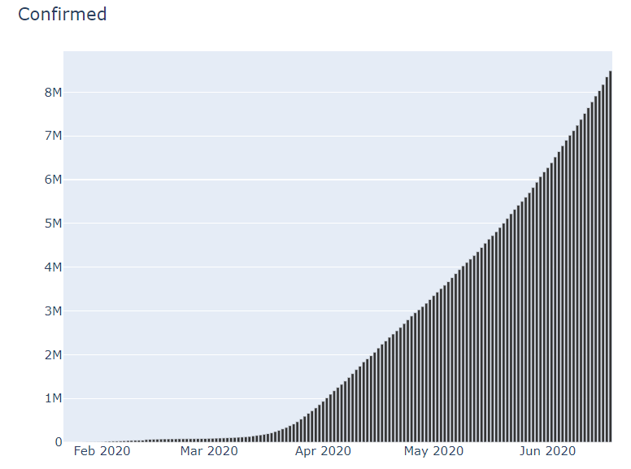

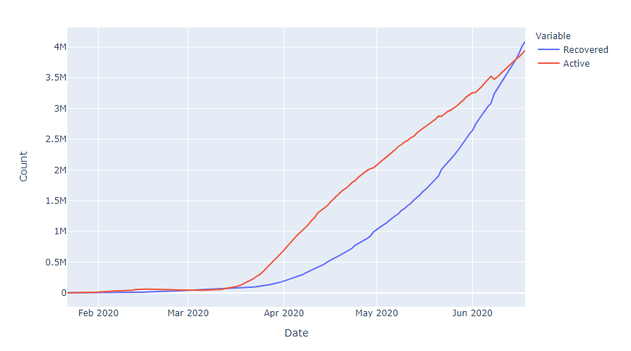

**DB : worldometer_data**

*Confirmed vs deaths, population vs confirmed*

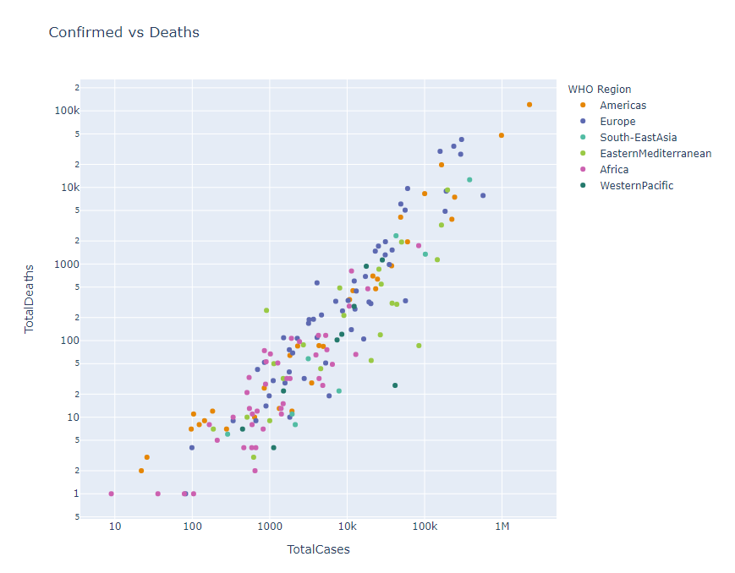

*Distribution of country wise no. of cases in different WHO Region*

